Loyalty Beyond Reason in Milan

The agenda for the 21st century is set. Massive shifts in power. From West to East, from centre to Edge. From manufacturer to retailer. And now from retailer to consumer.
Power has at last returned to the people, back where it belongs. We of the sixties were right.
And who are people looking to now? Government is largely a disappointing institution, today less trusted than business, too slow, too compromised, too contained, too distant from everyday sentiment.
No wonder Al Gore hit the eject button on politics. Give the man a simple computer application, and look what happens! A Noble Prize for PowerPoint!!
No, business is now the main event. This is the day of inclusive capitalism and this is the hour of sustainable enterprise, when your restless spirits and leadership light the way.
People are searching for a higher ideal, a movement to live for, and we are challenged to respond.
I’m going to share some ideas to take you beyond brands to a higher place.
Idea #1: Start with the Inspirational Dream
Martin Luther King did not say “I have a mission statement. “
Winning as a brand is not about respect and responsibility. It’s about love and inspiration.
Superb performance, bullet proof ethics, carbon neutrality… all table stakes. Crucial. But deferential not differential. Just skin in the game.
What’s next for brands is love and inspiration, real purpose, borne up by a dream.
- Dreams take your past and expand the horizon of possibilities.
- Dreams are imaginative, simple, memorable.
- Dreams draw people inside and outside to your purpose. They take everyone with you.
The bigger your dream, the higher you fly – as the company that invented brand management knows.

P&G Dream: “We make every day a little bit better by creating and building brands that people love.”

Saatchi & Saatchi: “To be revered as the hot-house for world-changing ideas that create sustainable growth for our clients.”
Idea #2: Drive Emotion Through the Core
Brands flourished in the rational world of benefits, with emotion as a clip-on. The advertising team was there to pipe on some emotional icing to add premiums.
We now know from countless studies that emotion drives every decision we make. The research vampires still don’t get it. In just 3 seconds, it’s over.
People are about 80% emotion, 20% reason.
The swing towards emotion is a worldwide trend as other sources of differentiation dry up. It’s won a Nobel Prize (for economist Daniel Kahneman), and the upside was seen some time ago…
- Toyota emotionalized QDR by Moving the World Forward.
- Wal-Mart is heading from “Low Prices, Always” to “Save Money, Live Better”.
- JCPenney is inspiring shoppers with 'Every day matters'.
Connect with emotion for explosive growth.

“Reason leads to conclusions, emotion leads to action.”
- Donald Calne
Idea #3: Work in the Attraction Economy
Where are we doing business in 2007?
From Information Economy, Knowledge Economy, Interruption Marketing (aka the Mass Market), Experience Economy, Attention Economy to the ATTRACTION ECONOMY.
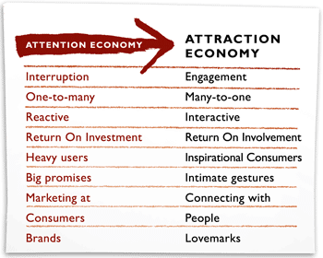
Idea #4: Reach for Love
Lovemarks are the future beyond brands. From products to trademarks to brands to Lovemarks.
- Brands create loyalty for a reason. Lovemarks create Loyalty Beyond Reason.
- Brands are built on Respect. Lovemarks are built on Love and Respect.
- Brands invest in Trust, Performance and Reputation. Lovemarks involve with Mystery, Sensuality and Intimacy.
- Brands are owned by managers, marketers and shareholders. Lovemarks are owned by the people who love them.
- Great brands are Irreplaceable. Lovemarks are Irresistible.

Idea #5: Do the Reality Check
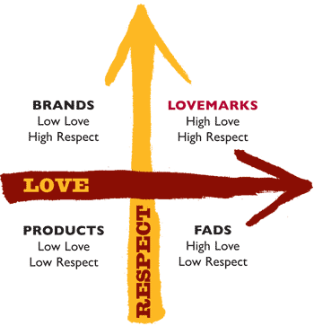
Where are you positioned in life?
Low Respect. Low Love. Commodities and utilities. No one wants to be here.
High Love. Low Respect. Fads and infatuations. This can be a terrific launching pad for massive growth if you can convert. Think of where mobile phones and texting started.
High Respect. Low Love. Where “e-r” words rule: faster, bigger, cheaper.
High Love and High Respect. Lovemarks where the future lies. Higher margins. Fantastic experience. Sustainable differentiation. Irresistible appeal. Loyalty Beyond Reason.
Idea #6: Use the Three Secrets
Mystery - the beguiling power of the unknown. Icons that connect, Dreams to inspire. Stories that matter.
The story is an ancient, mysterious and timeless art.
“The highest-paid person in the first half of this century will be the story-teller.”
- Danish futurist Rolf Jensen

An engaging story well told is priceless.
Sensuality - Lovemarks excite all five senses. Sight, sound, smell, touch and taste are portals to the emotions.
Starbucks was built on sensuality – and became the fastest-growing retail story of all time.
Apple sold its original iMac with tangerine taste. Yum!
And Intimacy - Empathy, commitment and passion. It’s the small touch, the perfect gesture that takes loyalty beyond reason.
Today’s website is yesterday's packaging disaster, the very opposite of intimate.
Above: TV commercial - Cold Stone Creamery 'Kid'
Idea #7: Hit the Accelerators
How do you get to the future first? By connecting fast! Here are six accelerators:
1 - Live in their world, not yours: Success is about what you feel, explore and discover – not what you know and see. Go past knowledge, get insight fast and turn it into foresight. At Saatchi & Saatchi we call this Xploring. Xploring gets to the truth of someone’s brand experience.
2 - Focus the Idea: Ideas are the currency of the future. We live in the Age of the Idea. Real ideas are simple, brave and big enough to live in any and many media. They have stopping power, talking and attracting power. They create platforms for sustained growth.
- Focus
- Reinvention
- Execution
- Delivery
- Accountability
The execution challenge is to connect a big idea with strategic partners on multiple scales.

EXAMPLE: iPod and the iPod halo have created $70 billion in shareholder value in just three years.
Innovation demands mojo and method. The method is: Fail fast, learn fast, fix fast.
3 - Stream Sisomo: Screens have got smart, mobile and connected. What matters most, is what comes through the screen. Sight, sound and motion, the world’s most potent connector. sisomo is what attracts, warms and connects. People don’t mind convergence, as long it converges on them. Keep the technology behind the screen, and pull people through it.
4 - Build a Theatre of Dreams: Worldwide, the store is an emotional desert. Turning shoppers into buyers is the next great creative opportunity. We set up Saatchi & Saatchi X to create Lovemarks in store. To transform with mystery, sensuality and intimacy and accelerate with sight, sound and motion. Saatchi & Saatchi is working with Wal-Mart to bring warmth and joy to shoppers, to attract them across the threshold.
5 - Choose Option A: Sustainability is the challenge of our time. Being Responsible about Sustainability is table-stakes. For business it’s a price of entry, and enforcing it on people is doomed to fail. Command and control won’t work for 6.6 billion people – and we’re out of time. Humanity needs a revolution, and business will deliver it, because we ignite the moment of choice. Sustainability will happen from the people up. It will be a groundswell and it will be inspired. Your job is to inspire people to make the right choices, to choose Option A - a Blue Planet. Doing good and doing well, do and will increasingly align. The alternative is Option B.
6 - Find Flow: The sweet spot between high responsibility and high inspiration is here on my axis of good and evil. (Mr. President, eat your heart out!) How to get there? By getting people in every enterprise, everywhere, every day into Flow. Flow happens when you unleash and inspire your people against the Dream. Flow is how you fix your short game and win the long game. Flow happens through Harmony from shared purpose and Passion for the Dream. Getting people “in the zone” dramatically increases productivity, creativity, longevity. The more people in flow, the higher you fly. None of us is as strong as all of us.
The Responsibility / Inspiration Axis:
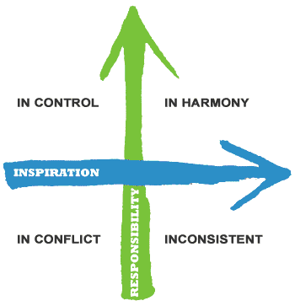
Idea #8: Make the World a Better Place for Everyone
"There is no way communism can compete with a salad shooter for $9.95."
- Colin Powell
The role of business is to make the world a better place for everyone. We have to look beyond management now, beyond leadership, which always requires followers.
Walk out of this room today an Inspirational Player, an inspirer of others. Let’s take people with us into a world of love and inspiration - before it’s too late.

